High Level Design (HLD) Realtime Health Guardian

Revision Number: 1.0

Last date of revision: 04/15/2024

Sachin Moze

# Document Version Control

|  |  |  |  |
| --- | --- | --- | --- |
| **Date Issued** | **Version** | **Description** | **Author** |
| **15th April 2024** | 1.0 | First Version of Complete HLD | Sachin Moze |
|  |  |  |  |
|  |  |  |  |
|  |  |  |  |
|  |  |  |  |
|  |  |  |  |
|  |  |  |  |

**Contents**

Document Version Control 2

Abstract 3

1. Introduction 5
   1. Why this High-Level Design Document? 5
   2. Scope 5
2. General Description 6
   1. Product Perspective & Problem Statement 6
   2. Tools used 6
3. Design Details 7
   1. Functional Architecture 7
   2. Optimization 8
4. KPIs 9
   1. KPIs (Key Performance Indicators) 9
5. Deployment 9

# Abstract

The Realtime Healthcare Guardian application represents a solution for personalized health monitoring, leveraging wearable technology to provide real-time insights into individuals' heart rates. By seamlessly integrating with Google Fit, the application facilitates the immediate transfer of heart rate data to the cloud, ensuring accessibility and reliability.

Through continuous monitoring of heart rate data, the system is equipped to detect abnormalities with precision and efficiency. Whether it's fluctuations in heart rate patterns or potential indicators of impending health issues, the application's algorithm swiftly identifies these signals. In response, emergency alerts are promptly send to family members via email and text messages, enabling timely intervention and support.

In addition to its alerting functionality, the application offers features designed to enhance user experience and promote proactive health management. Users can effortlessly add multiple family members' details. Real-time tracking of heart rate progress provides valuable insights into individual health track, while historical data analysis offers a holistic view of long-term health trends.

Furthermore, the application serves as a valuable resource for guiding users towards appropriate medical interventions when abnormalities are detected. By offering recommendations for medical consultation, the application empowers individuals to take proactive steps towards optimizing their health and well-being.

To access these transformative features, users are required to create an account and authenticate it with their Google account read specific data permission's only, ensuring a secure and seamless user experience. This streamlined authentication process underscores the application's commitment to user privacy and data security, fostering trust and confidence among its users.

# Introduction

## Why this High-Level Design Document?

The purpose of this High-Level Design (HLD) Document is to add the necessary detail to the current project description to represent a suitable model for coding. This document is also intended to help detect contradictions prior to coding, and can be used as a reference manual for how the modules interact at a high level.

The HLD will:

* + - Present all of the design aspects and define them in detail
    - Describe the user interface being implemented
    - Describe the hardware and software interfaces
    - Describe the performance requirements
    - Include design features and the architecture of the project
    - List and describe the non-functional attributes like:
      * Security
      * Reliability
      * Maintainability
      * Portability
      * Reusability
      * Application compatibility
      * Resource utilization
      * Serviceability

## Scope

The HLD documentation presents the structure of the system, such as the database architecture, application architecture (layers), application flow (Navigation), and technology architecture. The HLD uses non-technical to mildly-technical terms which should be understandable to the administrators of the system.

# General Description

## Product Perspective & Problem Statement

The Realtime Health Guardian application aims to provide personalized health monitoring using wearable technology. It addresses the need for real-time insights into individuals' heart rates and facilitates immediate alerts to family members in case of health emergencies.

## Tools used

The project utilizes various tools and technologies for data collection, analysis, and communication. These tools include Python programming language, Python Flask frameworks for web development, wearable technology integration, Google fit API integration and sqlite database for data storage and processing.



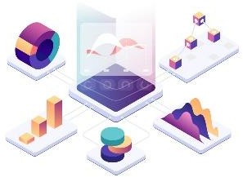

# Design Details

## Functional Architecture

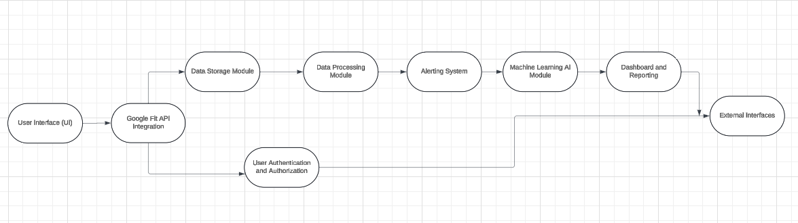

Figure 1: Functional Architecture of Business Intelligence

Below is how Google fit Authentication works

## Optimization

### Efforts are made to optimize the application for efficiency, accuracy, and user experience. This includes algorithm optimization for real-time processing, user interface design for ease of use, and system architecture design for scalability and reliability.

# KPIs

Dashboards will be implemented to display and indicate certain KPIs and relevant indicators of the heart rate analysis.

As and when, the system starts to capture the historical/periodic data for a user, the dashboards will be included to display charts over time with average heart rate plot.

## KPIs (Key Performance Indicators)

Key performance indicators for the Realtime Health Guardian application include.

1. Impact of real-time alert generation
2. Accuracy of abnormality detection
3. Response time for emergency alerts

# Deployment

The deployment phase involves deploying the Realtime Health Guardian application into production environments such as mobile devices and web servers. Considerations include security, scalability, reliability, and regulatory compliance.